


Functional Requirements Document (FRD)

Infinity Sports

,
Inc.
–

J898108

Copyright© 2018, Oracle and/or its affiliates. All rights reserved.
Any reproduction or distribution of any part of this document without the prior written permission of Oracle + NetSuite is strictly prohibited.
The information included in this document is confidential and proprietary information of Oracle + NetSuite. Version: March 3, 2022

Oracle + NetSuite
2955 Campus Drive, Suite 100
San Mateo, CA. 99403-2511

Project Information
Implementation Name | SS4C Customization
Customer Name (Number) | Infinity Sports, Inc.
Job Name (Number) | J898108
Document Owner | Aarti Joshi
Project Manager | Aarti Joshi
Lead Developer | Ilan Daniele

Document Version History
Rev | Date | Author(s) | Change Summary
1.0 | 03/02/2023 | Aarti Joshi | Initial Draft
1.1 | 03/07/2023 | Ilan Daniele | Additional Notes

Table of Contents
- Business needs ............................................................................................................................... 3
- Impacted areas/modules [Optional as output] ............................................................................... 3
- Acceptance criteria......................................................................................................................... 3
- Solution proposal ........................................................................................................................... 3
- Prerequisites .................................................................................................................................. 4
- Assumptions .................................................................................................................................. 4
- Constraints and limitations ............................................................................................................ 4
- Risks .............................................................................................................................................. 4

1 Business needs
Gun Accessory Supply is a wholesale distributor providing firearm accessories and sport optics through freight programs and financing options. They do not want to show the exact on hand qty to their customer and it should be displayed based on threshold value set.

Feature 1: Stock message feature
Modify the Product Detailed Page (“PDP”) to display a custom stock message according to product stock threshold values.

2 Impacted areas/modules [Optional as output]
PDP Module.

3 Acceptance criteria
- Custom stock quantity should be displayed in product detailed page.
- Stock quantity should be based on threshold value set.
- Show exact on- hand quantity if it is less than threshold value.
  - Show threshold value if on-hand quantity is above it.
  - Threshold value is 1000 and on hand quantity is 1500
  - Stock qty should be displayed as 1000+

4 Solution proposal
- Two threshold fields should be created to set the value
  - Global Level – this can be setup at website level
  - Item level – This will be setup at item level
- Item level threshold should take precedence over global threshold value.
- If item level threshold is not available, global threshold will apply.
- Quantity Available message will be displayed on section of PDP, as per threshold value set at global or item level.
Cases:
1. If item has item published threshold quantity:
- If on one item its quantity available exceeds the item published threshold quantity, the quantity available should be summarized and shown: Qty Available: “Threshold value+”.
As an example: Rio ammunition item has a quantity available of 1300, but it’s item threshold value is 1000, so Quantity Available message will be the following:

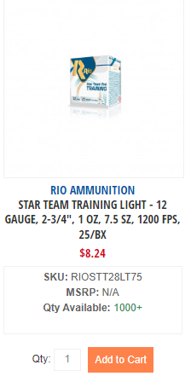
- If the quantity available on the item does not exceed the item published threshold quantity, quantity available message will be filled up by item’s available quantity. See example below:
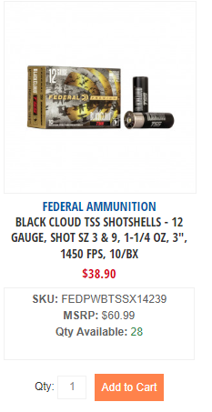
2. If item does not have item level threshold we will use global threshold, and case will be equal as above.

What if the product is out of stock?

5 Prerequisites
- Thresholds values will be setup and configurable by customer, and item should be enabled to the store.
6 Assumption
- Qty will be displayed based on on-hand stock for that product.

7 Constraints and limitations
- Not applicable

Risks
- Not applicable

Oracle + NetSuite Professional Services and Customer are in agreement that the information documented above is accurate and representative of the customer’s business needs. This document will act as the basis for all subsequent implementation activities.
Document delivery date: MM/DD/YYYY

